**Basaveshwar Engineering college (Autonomous),Bagalakote-587102**

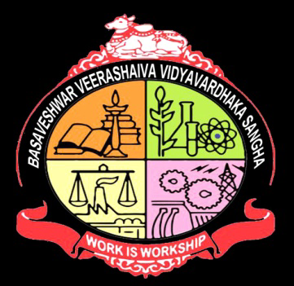

## Department of Electronics and communication

## CERTIFICATE

This is to certify that project entitled “**Mobile number tracing using python**” a bonafied work of **Miss.Varsha Mugati[2BA21EC118]** and **Miss. Samiksha Padasalagi[2BA21EC083].** The report satisfies the academic requirements with respect to project work prescribed for 3 semester during the academic year 2022 – 2023. It is a certified that all collections /suggestions indicated assessement of the project have been satisfied.

**PROJECT GUUIDE: HEAD OF THE DEPARTMENT**

PROF.M.C.ARALIMARAD DR.SHRIDHAR KUNTOJI

**SIGNATURE WITH DATE:**